**DATABASE**

A database is a collection of data which stores the data in an organized manner. It supports the retrieval, management and manipulation of data. In databases, the data are stored in the form of relations and each of them includes different fields. A database is usually controlled by a database management system (DBMS). Together, the data and the DBMS, along with the applications that are associated with them, are referred to as a database system.

Database system has wide varieties of applications in many fields including biology. In the field of Biology, the big data generated from modern molecular biology techniques, computational analysis and published literature are stored in biological databases, which make the data storage, access and analysis easier across the globe.

**DATABASE MANAGEMENT SYSTEM (DBMS)**

Database management system is a set of programs that used to manage the database. MySQL, PostgreSQL, Oracle are few examples of popular commercial DBMS. DBMS provides an interface to perform various operations like database creation, storing, processing and retrieval of data.

**FEATURES OF DBMS**

Efficient database management software may have the following features

* Low Repetition and Redundancy
* Data independence
* Concurrency Control
* Easy Maintenance of Large Databases
* Enhanced Security and recovery services
* Multi-User Environment Support

**STRUCTURED QUERY LANGUAGE (SQL)**

Structured Query Language (SQL) is a computer language that is used for creating, storing, manipulating, and retrieving data in a relational database. All DBMS like MySQL, Oracle, MS Access, Sybase, PostgreSQL use SQL as the standard database language for data handling. SQL contain several sub languages such as Data Manipulation Language (DML), Data Definition Language (DDL), Data Control Language (DCL), Data Query language (DQL) and Transaction Control Language (TCL)

***Creating nilgiri_med_plants database using PostgreSQL***

**To install PostgreSQL version 12.8. on Ubuntu 20.04**

*Sudo apt update*

*sudo apt install postgresql postgresql-contrib*

**To get into PostgreSQL**

To log in to the PostgreSQL server as the postgres user, first switch to the user and then access the PostgreSQL prompt using the psql utility:

*Sudo su - postgres*

*psql*

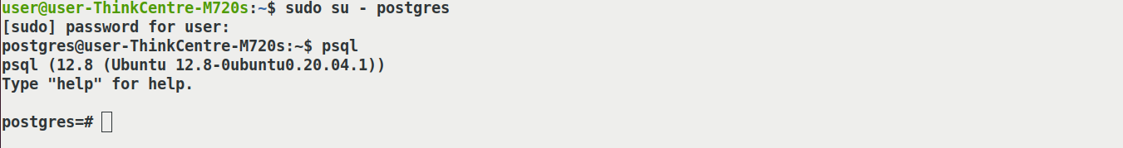

**nilgiri_med_plants database**

This database contains the medicinal plants used by tribals in Nilgiri district and parts of Western Ghats. The required data are collected from ----. The Nilgiri_med_plants database consists of the following tables. The relational schema for constructing the Nilgiri_med_plants database is given in Scheme 1

1. Names
2. Family
3. Habitat
4. Plant_parts
5. Uses

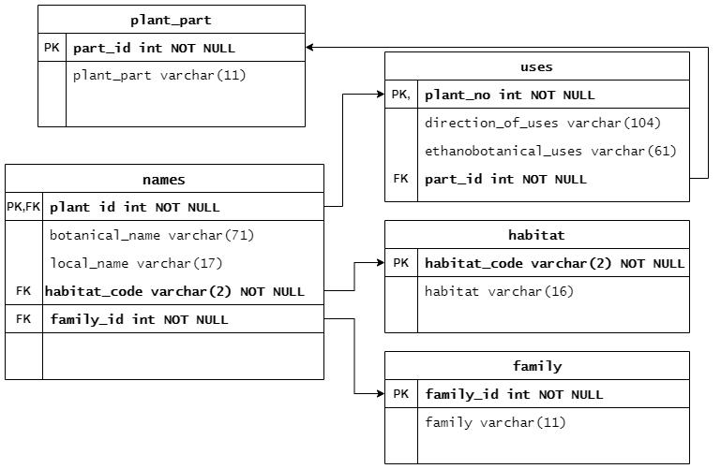

Scheme 1: The schema diagram for *nilgiri_med_plants* database. PK and FK refer to primary key and foreign key respectively.

**To create the *nilgiri_med_plants* database**

postgres=# *create database nilgiri_med_plants;*

**To list the databases**

postgres=#*\l*

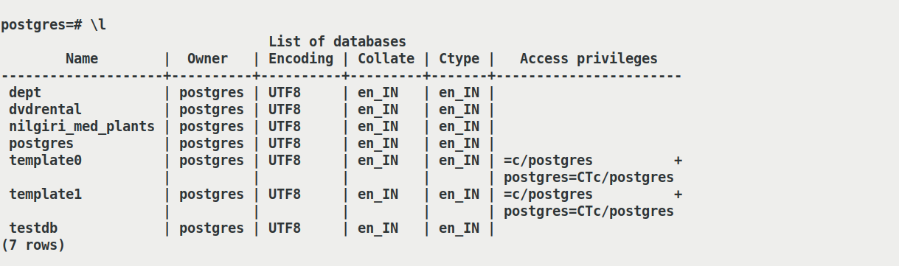

**To connect to the *nilgiri_med_plants* database**

postgres=#*\c nilgiri_med_plants*



**To create tables**

1. **Family**

nilgiri_med_plants=#*create table if not exists "family" ("family_id" numeric(4, 1),"family" text, Primary key (family_id));*



1. **Habitat**

nilgiri_med_plants=#*create table if not exists "habitat" ("habit_code" text,"habitat" text, primary key(habit_code));*



1. **Names**

nilgiri_med_plants=#*create table if not exists "names" ("plant_id" numeric(3, 1),"botanical_name" text, "local_name" text,"habit_code" text,"family_id" numeric(4, 1), primary key(plant_id), foreign key(habit_code) references habitat(habit_code));*



1. **Plant_part**

nilgiri_med_plants=#*create table if not exists "plant_part" ("part_id" numeric(4, 1) primary key,"plant_part" text);*



1. **Uses**

nilgiri_med_plants=#*create table if not exists "uses" ("plant_no" numeric(3, 1) primary key,"direction_of_use"text, "ethnobotanical_Uses" text,"used_part" numeric(4, 1),foreign key(used_part) references plant_part(part_id));*



**To List the tables in nilgiri_med_plants database**

nilgiri_med_plants=# *\d*

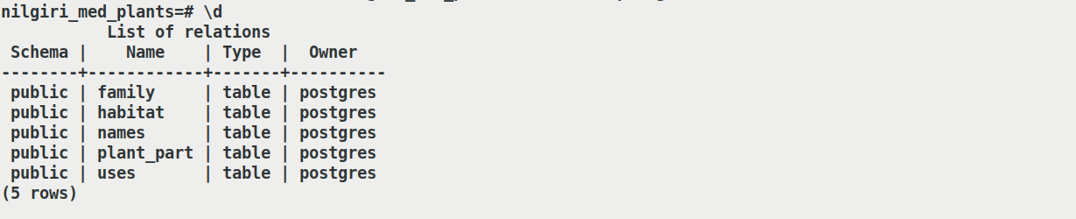

**To describe each tables**

nilgiri_med_plants=# *\d family*

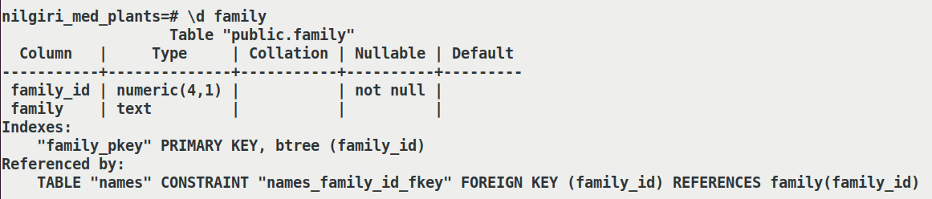

nilgiri_med_plants=# *\d habitat*

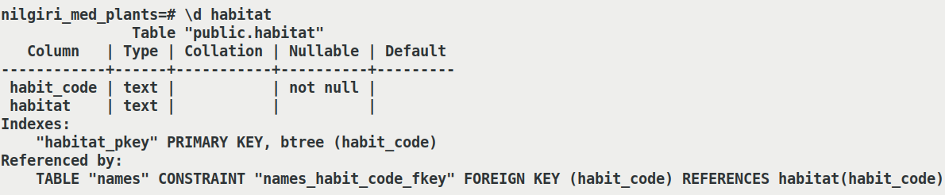

nilgiri_med_plants=# *\d names*

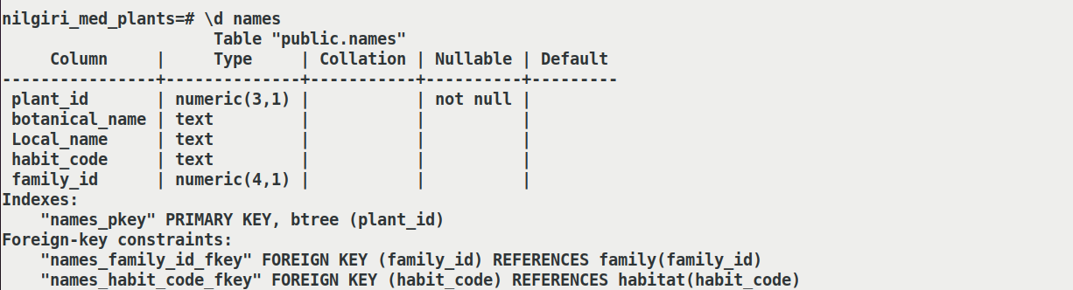

nilgiri_med_plants=# *\d plant_part*

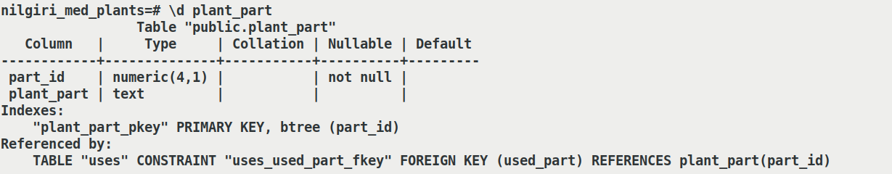

nilgiri_med_plants=# *\d uses*

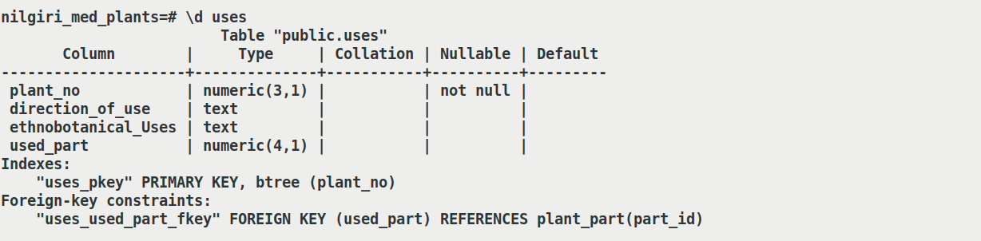

**To insert the records in to each table**

nilgiri_med_plants=#*insert into "family" values (101.0,'Liliaceae'),(102.0,'Pteridaceae'),(103.0,'Asteraceae'),(104.0,'Basellaceae');*



nilgiri_med_plants=#*insert into "habitat" values ('CS','Climbeing Shrubs'),('H','Herbs'),('TW','Twiners');*



nilgiri_med_plants=#*insert into "names" values (1.0,'Asparagus racemosus ','Sadhavari','CS',101.0), (2.0,'Actiniopteris radiata ','Mayilviri','H',102.0);*



nilgiri_med_plants=#*insert into "plant_part" values (201.0,'Leaves'),(202.0,'Whole plant'),(203.0,'Stem');*



nilgiri_med_plants=#*insert into "uses" values (1.0,'¾ of fresh cow milk with leaf paste is mixed and intaken','Cures White discharge for women',201.0), (2.0,'Whole plant is shade dried and powdered ', 'Removes stones from Urinary tract',202.0);*



***Creating a covid_vaccine database using MySQL***

**To install MySQL on Ubuntu 18.04**

*sudo apt update*

*sudo apt install mysql-server*

**To get into MySQL**

To log in to the MySQL server , first switch to the user and then access the MySQL prompt using the mysql utility:

*sudo mysql*

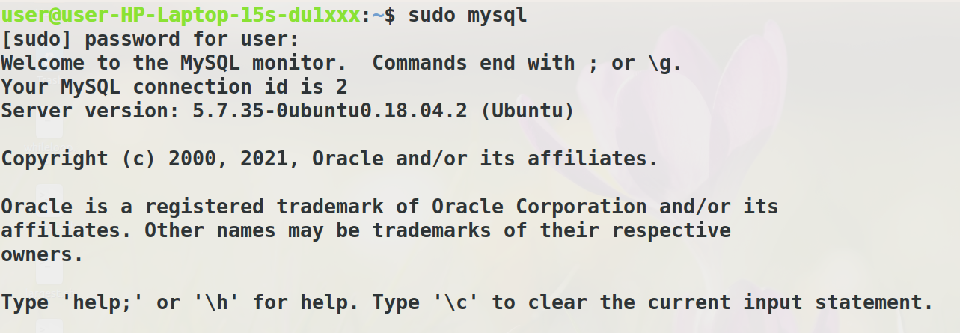

**covid_vaccine database**

The covid_vaccine database is created to store the information of the currently used vaccines and the vaccine candidates in the clinical trials against COVID 19. The data is collected from Li et al., 2021 *( Li, Y., Tenchov, R., Smoot, J., Liu, C., Watkins, S. and Zhou, Q., 2021. A comprehensive review of the global efforts on COVID-19 vaccine development. ACS Central Science, 7(4), pp.512-533).* The covid_vaccine database consists of the following tables and the relational schema for constructing the database is given below:

1 . DISTRIBUTION

2 . Advantages_disadvantages

3 . Examples

4 . Types_names

5 . Developer

6 . Full_forms

7 .candidates_in_clinical_trial

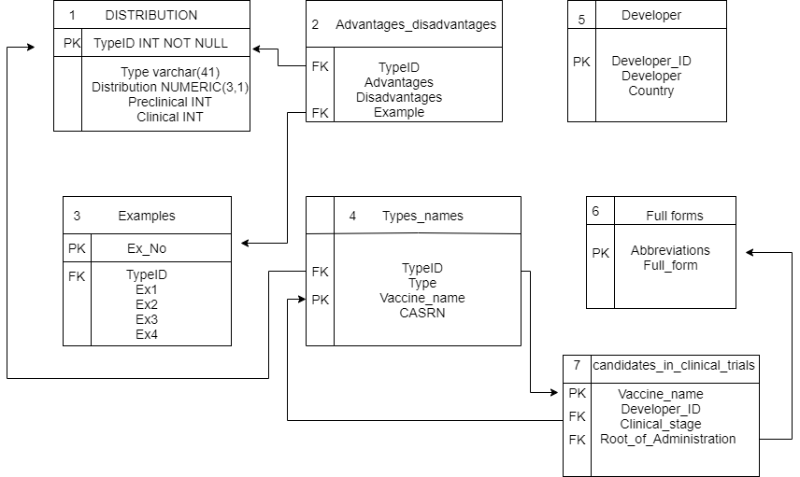

**To create the covid_vaccine database**

*mysql > create database covid_vaccine;*

**To list the databases**

*mysql >show databases;*

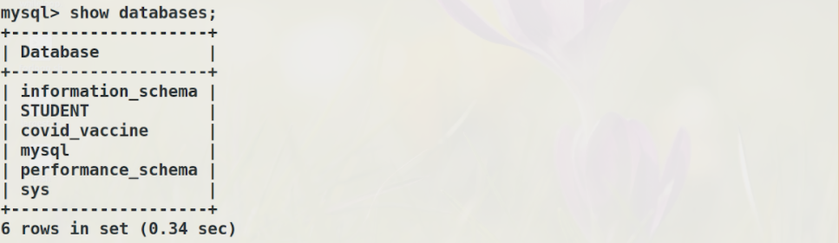

**To connect to the covid_vaccine database**

*mysql> use covid_vaccine database;*

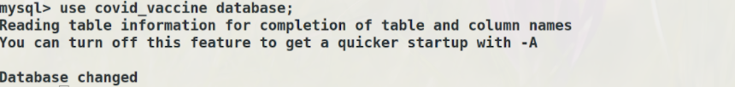

**To create tables**

mysql>CREATE TABLE Distribution_of_covid_vaccine (`Type_ID` INT, `Type` VARCHAR(41) CHARACTER SET utf8, `Distribution` NUMERIC (3, 1), `Preclinical` INT, `Clinical` INT, ‘Primary Key (Type_ID)’

);

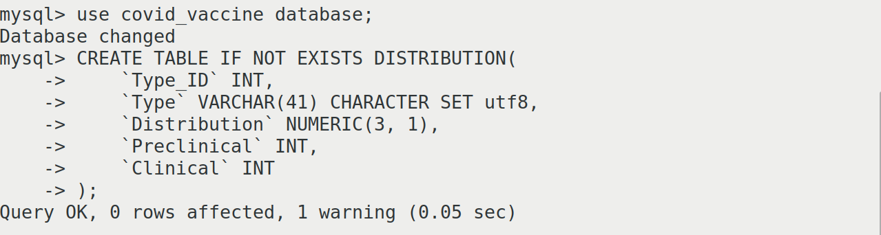

mysql>CREATE TABLE IF NOT EXISTS Advantages_disadvantages (

`ExNo` INT,

`Type_ID` VARCHAR(52) CHARACTER SET utf8,

`Advantages` VARCHAR(38) CHARACTER SET utf8,

`Disadvantages` VARCHAR(53) CHARACTER SET utf8,

`Example` INT

);

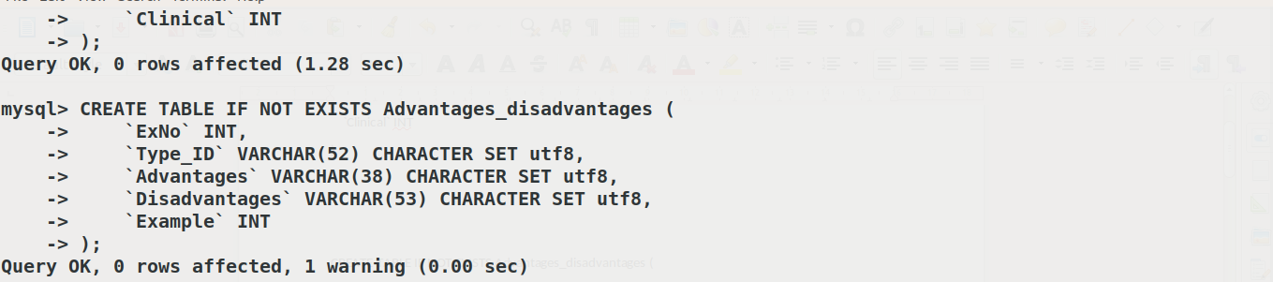

mysql>CREATE TABLE IF NOT EXISTS Examples (

`Ex_No` INT,

`Type_ID` VARCHAR(46) CHARACTER SET utf8,

`Example_1` VARCHAR(11) CHARACTER SET utf8,

`Example_2` VARCHAR(7) CHARACTER SET utf8,

`Example_3` VARCHAR(12) CHARACTER SET utf8,

`Example_4` VARCHAR(9) CHARACTER SET utf8

);

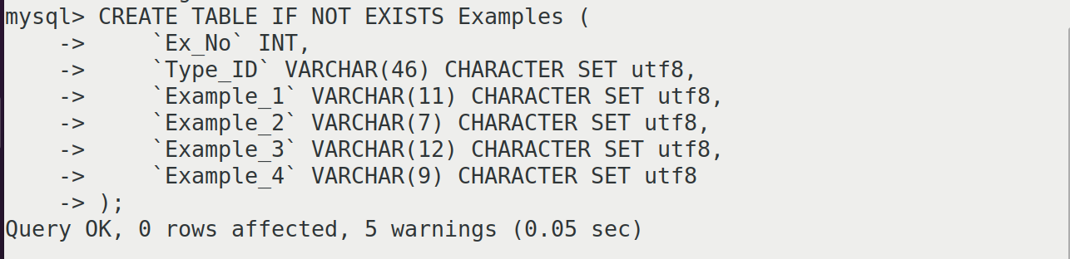

mysql>CREATE TABLE IF NOT EXISTS Types_names (

`Type_ID` INT,

`Type` VARCHAR(15) CHARACTER SET utf8,

`Vaccine_name` VARCHAR(11) CHARACTER SET utf8,

`CASRN` VARCHAR(12) CHARACTER SET utf8

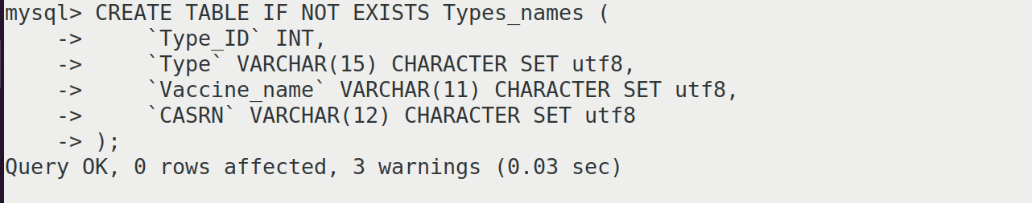

);

mysql>CREATE TABLE IF NOT EXISTS Developer (

`Developer_ID` INT,

`Developer` VARCHAR(49) CHARACTER SET utf8,

`Country` VARCHAR(6) CHARACTER SET utf8

);

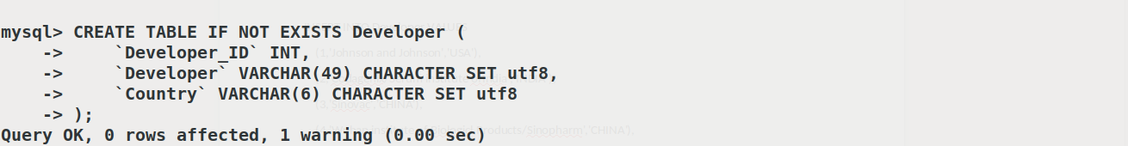

mysql>CREATE TABLE IF NOT EXISTS Full_forms (

`Abbreviations` VARCHAR(2) CHARACTER SET utf8,

`Full_form` VARCHAR(32) CHARACTER SET utf8

);

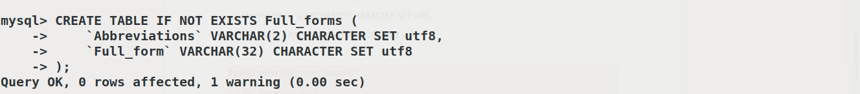

mysql>CREATE TABLE IF NOT EXISTS Candidates_in_clinical_trial (

`vaccine_name` VARCHAR(11) CHARACTER SET utf8,

`Developer_ID` VARCHAR(77) CHARACTER SET utf8,

`Clinical_stage` VARCHAR(7) CHARACTER SET utf8,

`Root_of_Administation` VARCHAR(2) CHARACTER SET utf8

);

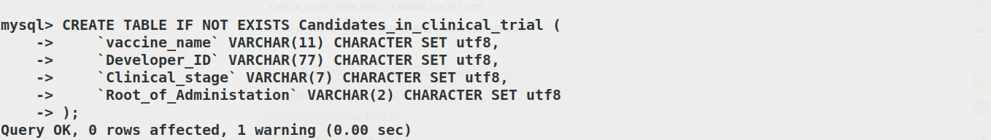

**Insert**

mysql>INSERT INTO Distribution_Of_COVID_Vaccine VALUES

(1001,'Protein based',35.9,68,24),

(1002,'Non replicating vector',13.3,22,12),

(1003,'Mrna',12.1,23,8),

(1004,'DNA',10.2,15,11),

(1005,'Replicating viral vector',9.8,19,6),

(1006,'Incactivated',8.2,11,10),

(1007,'VLP',7.8,18,2),

(1008,'Line attenuated',2,4,2),

(NULL,'Type ID is the Primary Key for this table',NULL,NULL,NULL);

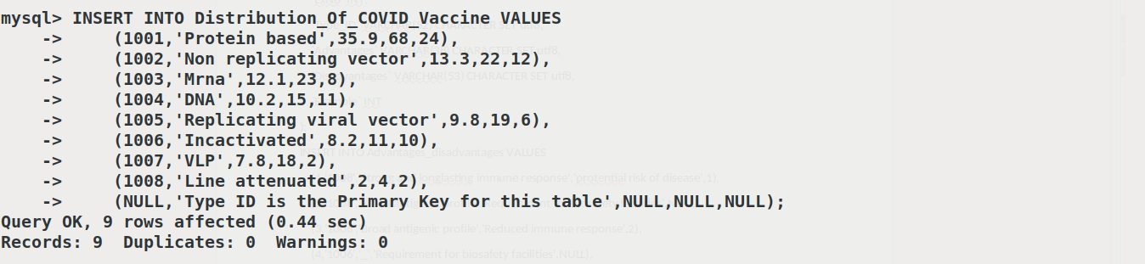

mysql>INSERT INTO Advantages_disadvantages VALUES

(1,'1008','Strong and longlasting immune response','protential risk of disease',1),

(2,'1008','Broad antigenic profile','Requirement for biosafety facilities',NULL),

(3,'1006','Broad antigenic profile','Reduced immune response',2),

(4,'1006','_','Requirement for biosafety facilities',NULL),

(5,'1006','_','Lower purity',NULL),

(6,'1001','Noninfectious','Limited capability in inducing cell mediated-immunity',3),

(7,'1001','Targeting key antigens','Adjuvent often needed',NULL),

(NULL,'Type ID is the Foreign Key referencing the table 1',NULL,NULL,NULL),

(NULL,'Example is a Foreign Key referencing table 3 (Ex No)',NULL,NULL,NULL);

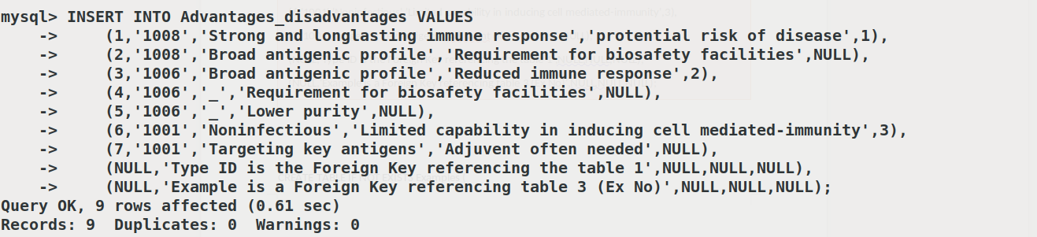

mysql>INSERT INTO Examples VALUES

(1,'1001','Smallpox','Measels','Tuberculosis','Polio'),

(2,'_','Hepatitis A','Polio','Rabies','Influenza'),

(3,'_','Hepatitis B','DTP','_','_'),

(NULL,'Ex No is the Primary Key',NULL,NULL,NULL,NULL),

(NULL,'Type ID is the Foreign Key referencing table 1',NULL,NULL,NULL,NULL);

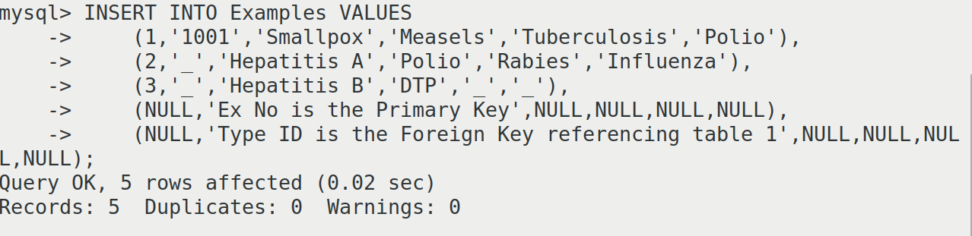

mysql>INSERT INTO Developer VALUES

(1,'Johnson and Johnson','USA'),

(2,'Codagenix/Serum institute ofIndia','INDIA'),

(3,'Sinovac','CHINA'),

(4,'Wuhan institute of Biologicl Products/Sinopharm','CHINA'),

(5,'Beijing Institute ofBiological Products/Sinopharm','CHINA'),

(6,'Bharath Biotech','INDIA'),

(7,'Erciyes University','TURKEY'),

(NULL,'Developer ID is the Primary Key',NULL);

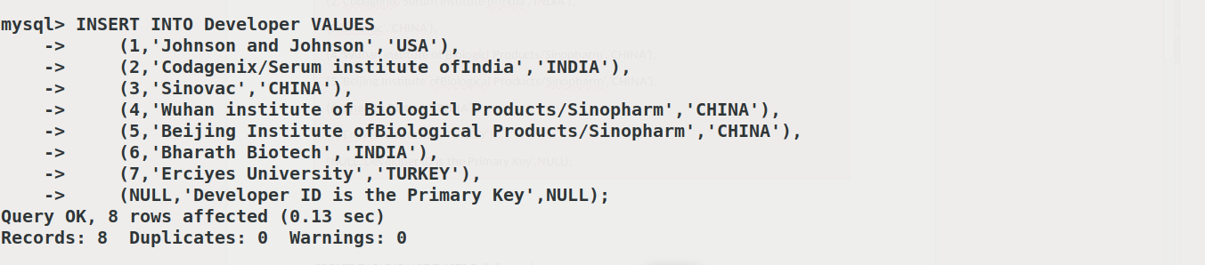

mysql>INSERT INTO Full_forms VALUES

('IM','intramuscular'),

('IN','intranasal'),

('SC','subcutaneous'),

(NULL,'Abbreviations is the Primary Key');

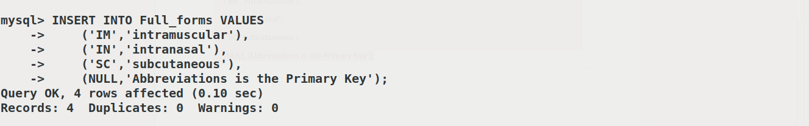

mysql>INSERT INTO Candidates_in_clinical_trial VALUES

('Astrazeneca','1','phase 4','IM'),

('COVI-VAC','2','phase 1','IN'),

('CoronaVac','3','phase 4','IM'),

('BBIBP-CorV','5','phase 3','IM'),

('Covaxin','6','phase 3','IM'),

(NULL,'Vaccine name is the Primary Key and Foreign Key referencing Table 4',NULL,NULL),

(NULL,'Developer ID is the Foreign Key referencing Table 5 ',NULL,NULL),

(NULL,'Root of Administration is the Foreign Key referencing Table 6 (Abbreviations)',NULL,NULL);

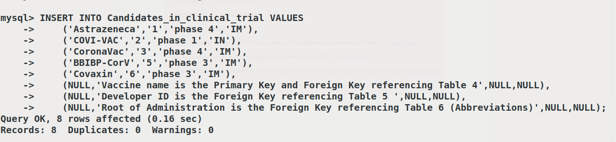

**Description about tables:**

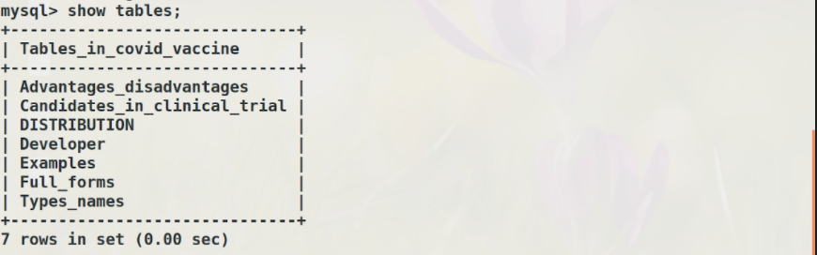

**Description of each tables**

DISTRIBUTION

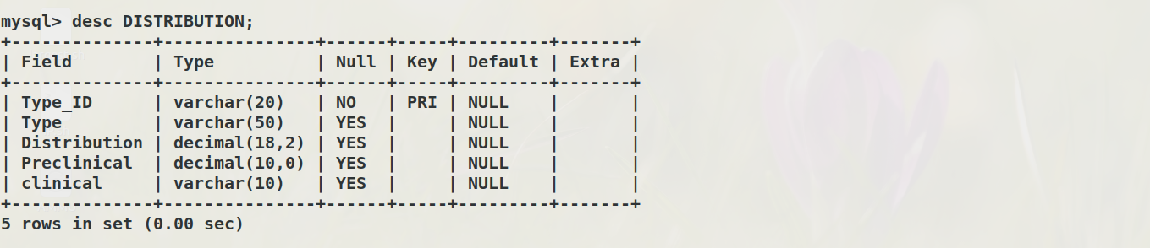

Advantages_disadvantages

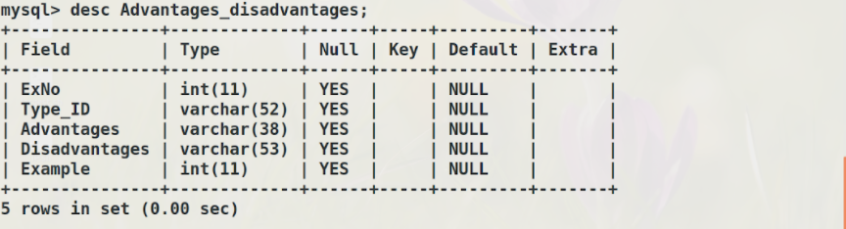

Candidates_in_clinical_trial

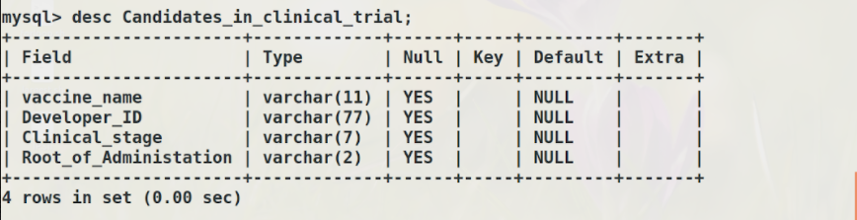

Developer

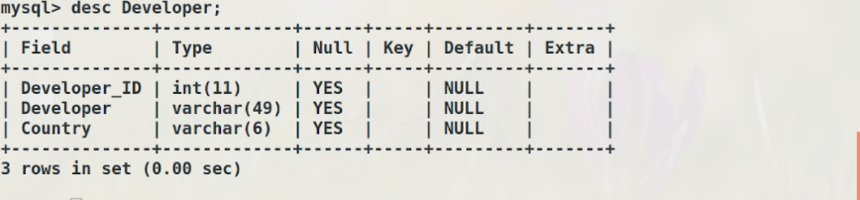

Types_names

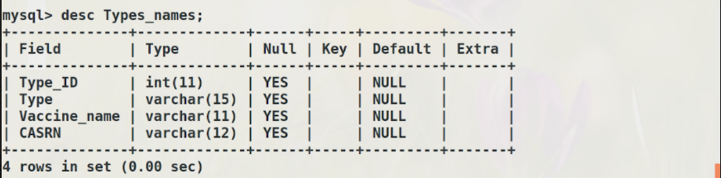

Full_forms

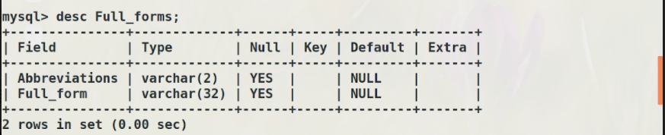

Examples

